Project Design Phase-II
Data Flow Diagram & User Stories

Date | 03 April 2026
Team ID | Team 1
Project Name | Automating Data Import and Relationship Mapping using Import Sets and Dot Walking
Maximum Marks | 4 Marks

Data Flow Diagrams:
A Data Flow Diagram (DFD) is a traditional visual representation of the information flows within a system. A neat and clear DFD can depict the right amount of the system requirement graphically. It shows how data enters and leaves the system, what changes the information, and where data is stored.

Example: Level 1 DFD Level 2 DFD
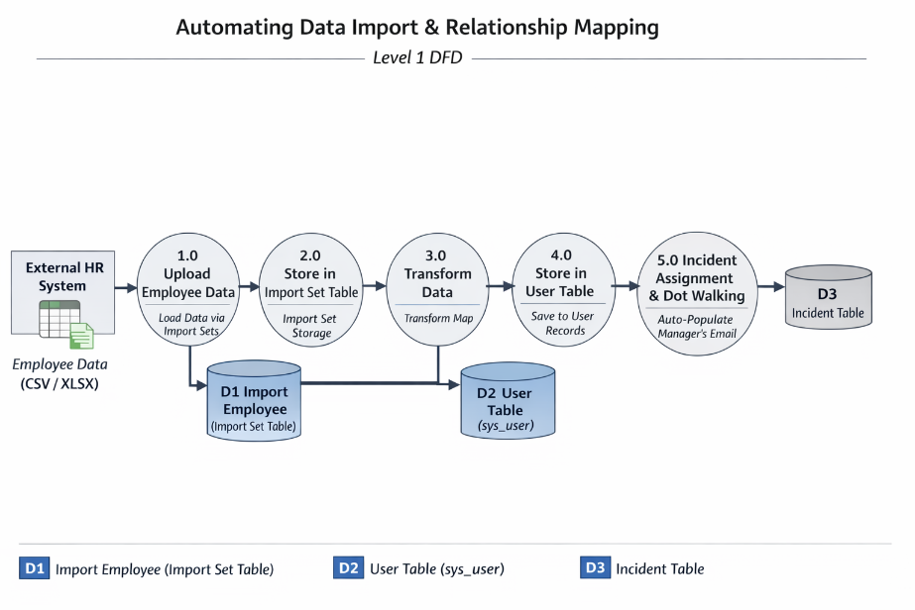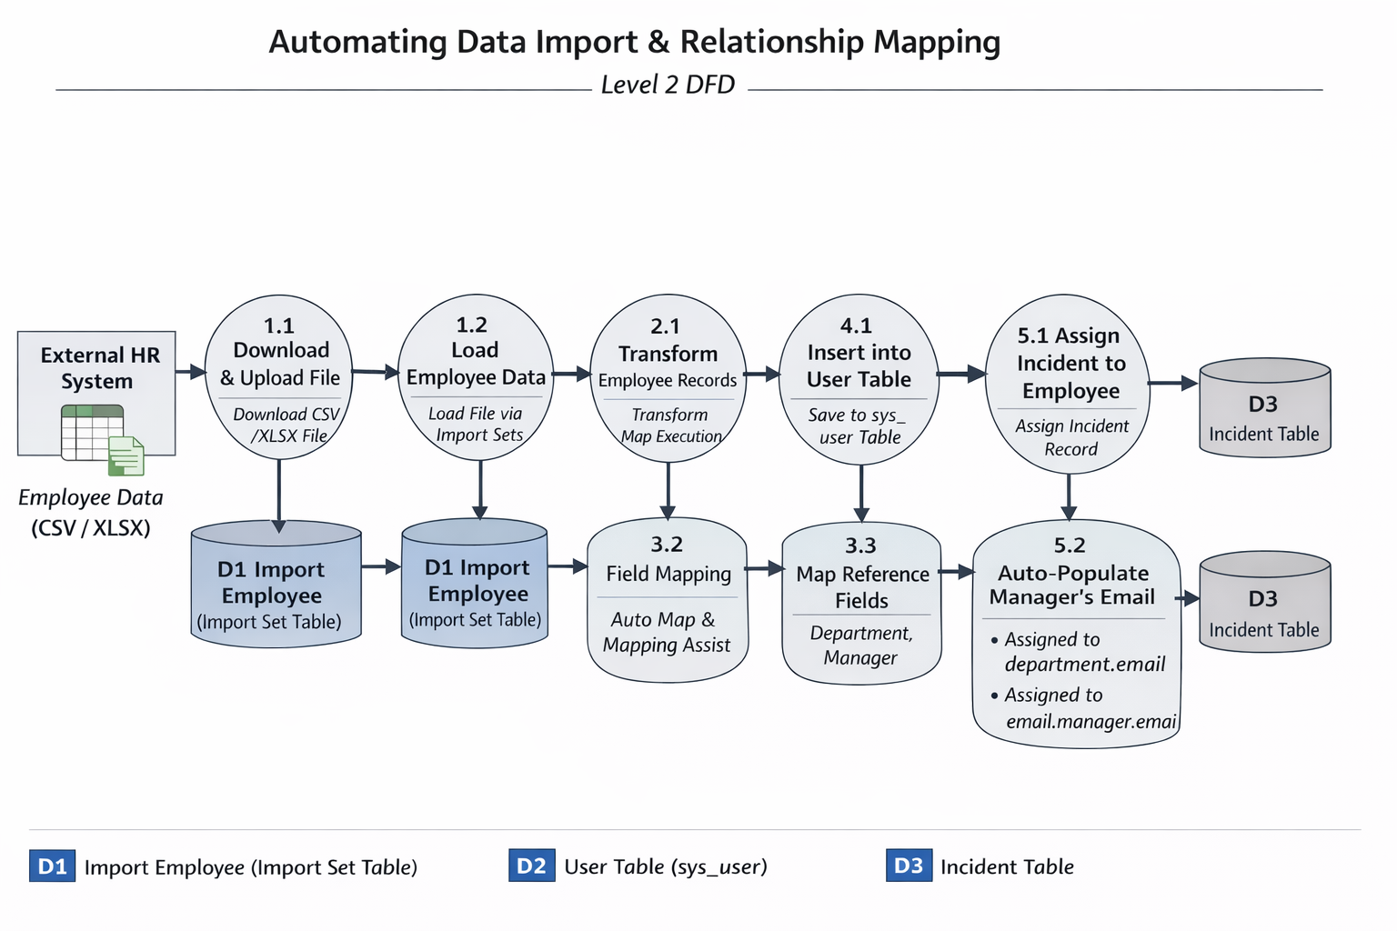

User Stories
User Type | Functional Requirement (Epic) | User Story Number | User Story / Task | Acceptance Criteria | Priority | Release
ServiceNow Admin | Data Import Setup | USN-1 | As a ServiceNow Administrator, I want to load a CSV file of employee data into an Import Set table named import_employee so that the external data is staged for processing. | 1. CSV is successfully uploaded via Load Data.  2. import_employee table is automatically generated with the raw data. | High | Sprint-1
ServiceNow Admin | Data Transformation | USN-2 | As a ServiceNow Administrator, I want to create a Transform Map linking the import_employee source table to the sys_user target table so that I can define how the data is migrated. | 1. Transform map is created and saved.  2. Source and Target tables are correctly defined. | High | Sprint-1
ServiceNow Admin | Data Transformation | USN-3 | As a ServiceNow Administrator, I want to map all standard and reference fields (department, manager) using Auto Map and Mapping Assist so that records are accurately linked in the system. | 1. Name, email, and phone map cleanly.  2. Department and Manager reference fields look up and link to the correct sys_ids in the target tables. | High | Sprint-1
ServiceNow Admin | Data Transformation | USN-4 | As a ServiceNow Administrator, I want to run the Transform Map and verify the output so that I know the employee records are successfully inserted into the user table. | 1. Transform runs without data truncation errors.  2. Employee profiles are visible and accurate in the sys_user table. | High | Sprint-1
ServiceNow Admin | Form Configuration | USN-5 | As a ServiceNow Administrator, I want to configure the Incident form layout using dot-walking so that related user details are exposed on the form. | 1. Assigned to.department, Assigned to.email, and Assigned to.manager are added to the Incident form view. | High | Sprint-1
IT Support Agent | Incident Management | USN-6 | As an IT Support Agent, I want the assigned employee's department, email, and manager to auto-populate when I assign an incident, so I have immediate context without opening their profile. | 1. Selecting an employee in the "Assigned to" field immediately displays their department, email, and manager's email on the form. | High | Sprint-1

